Augmented Reality (AR) And Virtual Reality (VR) Applications In Tourism: Embracing Emerging Technologies For Improved Tourist Experiences In Malaysian Tourism Industry

Juhanita Jiman
University Malaysia of Computer Science and Engineering, Malaysia

Salamiah Muhd Kulal
University Malaysia of Computer Science and Engineering, Malaysia

Abstract . This paper investigates the impact of Augmented Reality (AR) and Virtual Reality (VR) on the Malaysian tourism business. AR and VR have emerged as revolutionary forces, transforming a wide range of industries, with tourism at the forefront of this digital transition. Augmented Reality complements real-world experiences by superimposing digital information on top of the physical world, whereas Virtual Reality immerses users in simulated environment. AR and VR have completely transformed the tourist experience, including planning, booking, on-site exploration, and post-trip comments. AR applications enrich the tourist experience by providing interactive maps, historical insights, and real-time translations, whereas virtual reality (VR) technologies enable deep interaction in a variety of fascinating activities and provide a fascinating insight into the destination's attractions.

Keywords; Application of Augmented Reality (AR), Virtual Reality (VR), Tourist, Malaysian Tourism Industry

INTRODUCTION
Traditional tourism has always been an important part of human society, bringing a variety of benefits such as cultural exchange, revenue generation, and personal enrichment. However, with the introduction of Augmented Reality (AR) and Virtual Reality (VR) technology, the tourism business is undergoing substantial change. By providing immersive experiences, safeguarding cultural heritage, overcoming language hurdles, and supporting sustainable tourist practices, AR/VR integration has the potential to expand traditional tourism in Malaysia.
AR/VR integration can provide tourists with immersive experiences which enable them to digitally explore historical and cultural places before visiting them. This can assist tourists discover about the significance and history of these locations before they visit, making their visit more meaningful. For example, AR apps can provide virtual tours of Penang's UNESCO-listed George Town, allowing visitors to engage with virtual guides and learn about the city's rich history (Khoo et al, 2015). Similarly, VR can be used to develop virtual museums and exhibitions that showcase Malaysia's cultural and historical history to a global audience.
AR/VR can also help conserve and promote Malaysia's cultural heritage. Virtual tours and experiences can increase tourists' access to ecologically fragile and culturally sensitive locations without negative impact. Furthermore, AR/VR can be utilised to establish digital archives of cultural artifacts and sites, preserving them for future generations.
For tourists, language difficulties can be an enormous challenge. However, by providing translation apps and virtual language immersion experiences, AR/VR can help overcome these challenges (Ercan, 2020). AR translation apps can interpret street signs, food options, and conversations in real time, making Malaysia easier to access for tourists from all over the world. VR can also provide virtual language immersion experiences, which can assist travellers in becoming more culturally conscious prior to their trip.
AR/VR integration can also promote green tourism practices. AR/VR can assist in minimising the environmental impact of over-tourism on vulnerable ecosystems by giving virtual alternatives to physical experiences (Bec, Moyle, Schaffer, & Timms, 2021). Tourists, for example, can electronically visit Malaysia's beautiful rainforests or observe wildlife in their native habitats, reducing the need for physical trips, which might disturb local ecosystems.

BACKGROUND PROBLEM
Malaysia's tourism sector is eager to attract more visitors to both prominent and lesser-known sites, as well as to distinguish itself from competitors in the global tourism market. One of the issues confronting Malaysia's travel industry is the requirement of offering travelers with unique and immersive experiences.
Tourists are increasingly looking for authentic and personalised experiences that go beyond standard tourism. They desire to connect with the local culture, history, and environment in a meaningful way. Traditional means of distributing information and experiences, on the other hand, may not always fulfil these changing demands. (Zkul & Kumlu, 2019)
Brochures, tour guides, and audio guides are examples of traditional means of delivering information and experiences in the tourism industry that have limitations in terms of interactivity and engagement. They frequently present static and generic information that may not be customized to the specific preferences and interests of travellers. Furthermore, Malaysia's tourism industry confronts the difficulty of attracting additional visitors to both renowned and lesser-known places. While renowned tourist locations such as Kuala Lumpur and Langkawi draw a large number of visitors, Malaysia has many other attractive and culturally rich destinations that are largely untouched.
Tourists usually have insufficient knowledge and awareness of these hidden treasures, and as a result, they may miss out on the unique experiences that these sites have to offer. (Grundner & Neuhofer, 2021) Furthermore, Malaysia's tourist industry must distinguish itself from competitors in the global tourism market. With the advent of AR and VR technology, Malaysia's tourism industry now has the chance to address these difficulties and improve tourist experiences by implementing these technologies.

LITERATURE REVIEW
The tourism industry in Malaysia is a significant contributor to the country's economy. According to the WEF Travel and Tourism Competitiveness Report 2017 (WEF, 2017), tourism accounted for 4.4% of Malaysia's GDP in 2017 amounting up to US $13,004.3 million and provided jobs for 574,182 people. The rapid advancements in technology, particularly in the field of Augmented Reality and Virtual Reality, have opened up new possibilities for enhancing the way tourists experience and engage with destinations. Virtual and Augmented Reality (AR/VR) applications have gained significant recognition in various fields, including the tourism industry (Yerden & Uydaci, 2022).
Malaysian tourism has a fascinating history, evolving from traditional to contemporary digital applications, where the digital age has profoundly shifted the Malaysian tourism landscape. (Adeyinka-Ojo, Lee, Abdullah, & Teo, 2020) Historically, Malaysia's rich cultural heritage, natural landscapes, and traditional practices have captivated visitors for decades. From showcasing the diverse traditions of its indigenous peoples to presenting the allure of its tropical rainforests and pristine beaches, Malaysia has long been a captivating tourist destination.
The integration of AR and VR technologies in the Malaysian tourism industry has the potential to revolutionise the way tourists experience destinations. According to several sources, including "How the travel industry can use eCommerce to its advantage" and "5 ecommerce tips", the integration of AR and VR technologies in the tourism industry can enhance user experience and improve tourist satisfaction . By offering a more immersive and interactive experience, AR and VR applications can captivate tourists and leave a lasting impression (Moiseeva, 2019).
Researchers in the travel and tourism domain are encouraged to re-evaluate strategies for reviving and promoting tourism in Malaysia by embracing innovative approaches. Taking advantage of the ongoing technological revolution, the widespread influence of social media, and the numerous advantages of ARand VR to create new and innovative opportunities. The integration of smart tourism principles can significantly impact not just the tourism sector, but also the broader economy, directly influencing the country's GDP growth. Furthermore, the fusion of social media and AR into tourism marketing amplifies Malaysia's attractiveness as a destination with substantial technological potential. This enables the portrayal of the country in an authentic light, allowing potential tourists to comfortably explore diverse videos, images, and reviews of the destination before their actual visit. (Abumandil, Ekmeil, Younus, & Alkhawaja, 2022).
AR and VR applications in tourism are transforming the way tourists explore and engage with destinations. AR overlays digital information onto the real world, providing tourists with interactive maps, guides, and historical insights. Virtual reality offers immersive simulations of destinations, allowing tourists to virtually experience them before planning a trip. (Neuburger, Beck, & Egger, 2018) These technologies have the potential to alleviate overcrowding and congestion in famous tourist spots while also teaching visitors about local cultures and the environment.
AR is being utilized to improve the visitor experience in a variety of ways. AR apps, for example, can give travelers with interactive maps and guides that highlight sites of interest, provide historical context, and offer real-time translation services (Gretzel, Werthner, & Koo, 2015; Xiang, Fesenmaier, & Gretzel, 2017). This can help travelers better understand and appreciate the places they visit, and AR apps can also be used to give real-time translation services to tourists, removing the need for physical guidebooks and interpreters (Gretzel, Werthner, & Koo, 2015). This can help to lessen tourism's environmental impact while also promoting cultural understanding. Furthermore, VR experiences can be applied to highlight sustainable tourism activities such as ecotourism and cultural tourism, pushing tourists to make environmentally responsible choices when travelling (Gretzel, Werthner, & Koo, 2015).
Furthermore, AR can be used to develop gamified experiences that make the trip more enjoyable and engaging. AR treasure hunts, for example, might be used to direct tourists around a city or historical site, whereas AR scavenger hunts can assist tourists learn about various facets of a culture. Visitors will find tourism more memorable and delightful as a result (López-Bentez & Buhalis, 2017).
On the other side, virtual reality (VR) is being used to alter the tourism industry. VR experiences, for example, can transfer tourists to other regions of the world, allowing them to virtually explore destinations before booking a vacation (Buhalis & Amaranggana, 2014; Pearce, 2018). This can assist travellers in making more informed decisions regarding their travel plans and avoiding disappointment once they get at their location.
Immersive simulations of sports such as hiking, scuba diving, and skiing is also feasible with VR. This allows tourists to experience destinations in novel and fascinating ways, even if they are unable to participate in specific activities (Gretzel, Werthner, & Koo, 2015).

Factors Affecting Tourist Experiences In The Malaysian Tourism Industry
To fully understand the potential impact of AR and VR applications on the Malaysian tourism industry, it is necessary to first evaluate the aspects that currently influence tourist experiences in Malaysia. Several factors can impact the tourism experiences in Malaysia. These factors include:
- Safety and Security- The safety and security of tourists is a critical factor that can impact their experiences in the Malaysian tourism. Ensuring the safety and security of tourists is essential in order to provide them with a positive and enjoyable experience. Osman, et al (2023) highlight the significance of safety and security issues in the tourism industry in Malaysia. This factor becomes particularly relevant when considering the global pandemic situation where health and safety concerns are heightened.
- Cultural Communication and Language Barriers- Cultural communication plays a crucial role in enhancing tourist experiences in Malaysia. Effective communication between tourists and locals is essential for a fulfilling tourism experience. Sulong et al (2023) emphasise the importance of cultural communication and overcoming language barriers in the Malaysian tourism industry.
- Accessibility and Infrastructure- The accessibility of tourist destinations and the availability of well-developed infrastructure can greatly impact tourist experiences in Malaysia. Access to transportation, accommodations, and tourist attractions is crucial for providing a seamless and enjoyable experience for tourists. Biswas et.al (2020) stress on the significance of improving accessibility and infrastructure in the Malaysian tourism industry. The ease of access and quality of infrastructure in terms of transportation systems, accommodations, and tourist attractions are crucial factors that determine the overall experience of tourists in Malaysia.
- Natural and Cultural Attractions- The natural and cultural attractions offered by Malaysia are key factors that contribute to tourist experiences. The diverse natural landscapes, rich cultural heritage, and historical sites in Malaysia attract tourists from around the world. Dey et. Al (2020) highlight the significance of natural and cultural attractions in attracting tourists to Malaysia.
How AR and VR Can Transform the Malaysian Tourism Industry
The tourism sector has enormous potential AR and VR applications. Tourists can use AR to acquire precise and visceral local information, which improves their understanding and appreciation of the places they visit (Shih & Chen, 2020). AR can overlay historical knowledge, interesting facts, and interactive features onto real-world settings, offering travellers with a more contextualised and enriched experience. In contrast, VR provides an immersive experience in which users may navigate and explore virtual landscapes that match real-life tourist sites. Tourists can virtually visit sites that might normally be inaccessible or difficult to reach, such as fragile or rural areas.
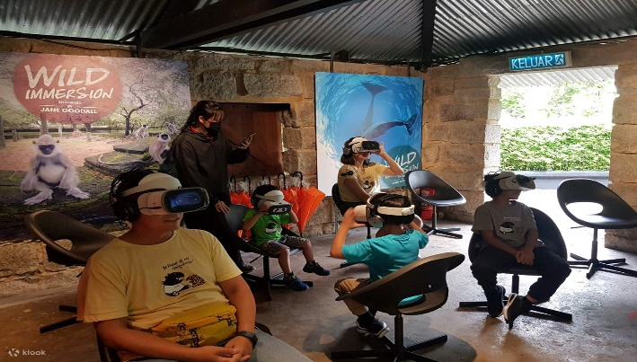
Figure 1: Wild Immersion Virtual Reality Experience at Penang Hill

In terms of safety and security, adding AR and VR technology into tourism can function as a training and instructional tool for tourists (Moiseeva, 2019). VR simulations, for example, can be used to educate tourists with local customs, traditions, and cultural practices prior to their actual visit. Not only does this enhance cultural understanding, but it also guarantees that tourists are well-prepared and considerate when engaging with the local people. AR and VR can improve tourism safety and security by delivering real-time information about hazards and emergency procedures. AR apps superimpose safety information onto the real environment, increasing tourists' awareness of their surroundings. Tourists can learn about emergency procedures in a safe atmosphere by using VR for immersive training sessions.
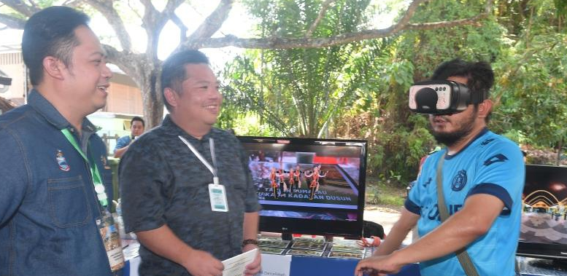
Figure 2- UMS and Sabah Cultural Board Use Augmented Reality to showcase culture

The use of AR and VR in the tourism industry can help improve communication and engagement between tourists and their surroundings. These technologies can allow tourists to interact with virtual 3D scenes or entities, making the experience more immersive and participatory (Shih & Chen, 2020). Virtual tour guides, interactive maps, and digital signs, for example, can provide real-time information on places of interest, directions, and recommendations.This not only improves the convenience and accessibility of tourism experiences, but it also allows tourists to get a taste of what to expect while visiting Malaysia,enhancing their interest and motivation to visit the country. Furthermore, the use of AR and VR in tourism can raise awareness and promote tourism locations through virtual previews
.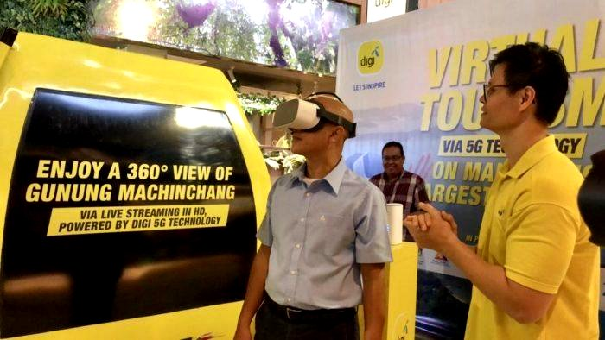
Figure 3- Digi, Malaysia Airports and Panorama Langkawi bring tourism to life through VR

VR can be used to construct realistic and immersive simulations of tourism destinations, allowing potential tourists to experience the destination before deciding to travel (Yerden & Uydaci, 2022). VR can help tourists make smarter travel decisions by providing virtual tours and previews. Furthermore, AR and VR technologies have the potential to broaden global contacts between travellers. Tourists can interact and share their experiences in real-time with others from all over the world by using virtual reality platforms and augmented reality applications, generating a sense of community and connection among them.
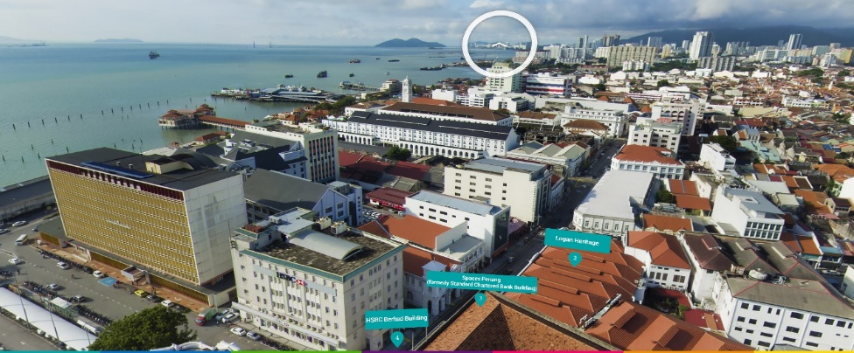
Figure 4- Welcome to Penang VR’ Initiative

Incorporating AR and VR technology in tourism industries can also help to attract and engage younger generations, such as Millennials and Generation Z. These generations are known to value exclusive and immersive experiences, which AR and VR technologies provide. These technologies offer personalised and interactive experiences that correspond to the preferences and expectations of younger travellers. However, it is crucial to emphasize that the adoption and implementation of AR and VR in the tourism business may face hurdles, particularly in rural or less developed areas with limited access to technology and internet connectivity. Furthermore, the costs of integrating AR and VR technology can be too expensive for smaller tourism enterprises or areas with limited resources.
The potential benefits of AR and VR in tourism cannot be overlooked as technology advances and becomes more accessible (Handbook of Technology Application in Tourism in Asia, 2022). AR and VR have emerged as key technologies with enormous potential in improving tourist experiences in Malaysia. The use of AR and VR technology in tourism has the potential to transform the way travellers discover and interact with destinations by providing immersive and interactive experiences that go beyond traditional sightseeing.
The capacity to give travelers with detailed and intuitive local information is one of the primary benefits of AR and VR technologies in the tourism industry (Shih & Chen, 2020). AR can provide tourists with real-time information about attractions, historical sites, restaurants, and other points of interest by superimposing relevant details on real-world objects. This improves their comprehension and appreciation of the destination. Furthermore, AR and VR technology can provide virtual tours and simulations of tourism places, allowing visitors to explore and experience a region before visiting it.
Tourism agencies may develop virtual experiences that closely resemble real-life experiences by using AR and VR technologies, offering tourists a taste of what to expect and enticing them to visit in person. Furthermore, AR and VR technologies have the potential to improve communication and engagement between tourists and destinations. These technologies may enable virtual interactions with local guides, who can provide real-time guidance and recommendations. Tourists can use VR to experience a destination from the comfort of their own homes. This is especially useful for people with restricted mobility or who are unable to travel owing to a variety of factors. Furthermore, the usage of AR and VR technology can assist in overcoming constraints associated with poor internet connectivity.
AR and VR technology can also provide offline material that can be accessed without requiring an internet connection in rural or vulnerable places with limited internet connectivity. This ensures that travellers can still access necessary information and have immersive experiences even when internet availability is limited.
Furthermore, AR and VR technologies have the potential to assist Malaysian in tourism promotion and marketing. These technologies, such as VR and AR apps, can be used to generate compelling and interactive promotional materials. These media can highlight Malaysia's distinctive sights and experiences, providing potential tourists an idea of what to expect. Furthermore, AR and VR technologies can be utilised to instruct and guide tourists (Moiseeva, 2019). AR and VR can be used to give training simulations for tour guides, allowing them to become acquainted with the destination and improve their knowledge and skills. AR and VR technology can also be utilized to develop virtual guides for tourists, offering them dynamic and engaging content.
AR and VR Challenges and Drawbacks in Malaysian Tourism Industry
Implementing AR and VR in Malaysia's tourism industries involves a number of issues that must be addressed for successful integration and acceptance. One of the most significant challenges is infrastructure preparedness. Adequate technical infrastructure, such as high-speed internet access and appropriate devices, must be available across Malaysia's many tourist sites for these technologies to work efficiently. Furthermore, significant investment is required in generating AR and VR content designed particularly for the Malaysian tourist market. Creating immersive and culturally appropriate experiences that highlight Malaysia's unique attractions, history, and cultural heritage is part of this.
The cost of integrating AR and VR technologies might be too expensive for smaller tourist operators or facilities, demanding financial assistance or incentives to stimulate their adoption. Furthermore, assuring user accessibility and resolving possible privacy and data security concerns, as well as the need for user education regarding AR/VR experiences, are critical for greater acceptability among tourists. To overcome these hurdles, government agencies, tourism organisations, technology developers, and players in the Malaysian tourism industries must work together to achieve the full potential of AR and VR for improving visitor experiences in Malaysia.
The application of AR and VR in tourism has various drawbacks that must be addressed. For instance, these technologies may instill overly high expectations in travellers; for example, a virtual reality hotel room tour may give an exaggeratedly pleasant appearance, leading to disappointment upon arrival. Furthermore, the addictive nature of AR and VR may lead to excessive gadget usage, preventing tourists from experiencing the real ‘taste’ of local culture and sights and resulting in wasted opportunities. Furthermore, the immersive nature of these gadgets may separate travellers from their companions, restricting interaction and shared experiences and negatively influencing the entire trip experience.

CONCLUSION
AR and VR are two emerging technologies that are influencing tourism industries around the world, including Malaysia. These technologies provide novel approaches to improve tourist experiences, promote Malaysian tourism, and eliminate travel barriers. AR and VR can take tourists to the heart of Malaysia's unique culture and gorgeous scenery by providing immersive and interactive experiences. AR apps may superimpose digital information on the real environment, allowing travellers to learn about historical sites, natural wonders, and cultural practices in a fun and engaging way. VR experiences can take tourists on virtual tours of major attractions such as Penang Historical City, Langkawi, and others, as well as difficult-to-access locations such as Mulu National Park, Taman Negara, and other remote places. AR and VR can also assist in overcoming travel constraints. Tourists with restricted internet access can still use AR apps to learn about Malaysian sights. Tourists with mobility issues or those who are unable to travel can still enjoy the beauties of Malaysia through VR experiences. In addition, AR and VR can be used to promote and market Malaysian tourism. AR and VR have the potential to revolutionise the Malaysian tourism industry, but there are some potential downsides, such as the cost of developing and implementing AR and VR applications, accessibility issues, technical challenges, and privacy and security concerns. The Malaysian government and tourism industry should work together to address these challenges and ensure that AR and VR are used in a responsible and ethical manner. Although AR and VR have the potential to transform the Malaysian tourism industry, there are numerous potential drawbacks, including the cost of developing and implementing AR and VR apps, accessibility issues, technological challenges, and privacy and security concerns. Malaysia's government and tourism industry should collaborate to address these issues and ensure that AR and VR are used responsibly and ethically.

REFERENCES:
Abumandil, M., Ekmeil, F. A. R., Younus, A. M., & Alkhawaja, M. I. (2022). Mobile augmented reality elements and social media usage on smart tourism in Penang: Malaysian. ECS Transactions, 107(1), 10935.
Adeyinka-Ojo, S., Lee, S., Abdullah, S. K., & Teo, J. (2020). Hospitality and tourism education in an emerging digital economy. Worldwide Hospitality and Tourism Themes, 12(2), 113-125.
Bec, A., Moyle, B., Schaffer, V., & Timms, K. (2021). Virtual reality and mixed reality for second chance tourism. Tourism Management, 83, 104256.
Biswas, C., Omar, H., & Rashid-Radha, J. Z. R. R. (2020). THE IMPACT OF TOURIST ATTRACTIONS AND ACCESSIBILITY ON TOURISTS'SATISFACTION: THE MODERATING ROLE OF TOURISTS'AGE. Geo Journal of Tourism and Geosites, 32(4), 1202-1208.
Buhalis, D., & Amaranggana, A. (2015). Smart tourism destinations enhancing tourism experience through personalisation of services. In Information and Communication Technologies in Tourism 2015: Proceedings of the International Conference in Lugano, Switzerland, February 3-6, 2015 (pp. 377-389). Springer International Publishing.
Dey, B., Mathew, J., & Chee-Hua, C. (2020). Influence of destination attractiveness factors and travel motivations on rural homestay choice: the moderating role of need for uniqueness. International Journal of Culture, Tourism and Hospitality Research, 14(4), 639-666.
Ercan, F. (2020). An examination on the use of immersive reality technologies in the travel and tourism industry. Business & Management Studies: An International Journal, 8(2), 2348-2383.
Gretzel, U., Werthner, H., Koo, C., & Lamsfus, C. (2015). Conceptual foundations for understanding smart tourism ecosystems. Computers in Human Behavior, 50, 558-563.
Gössling, S. (2002). Global environmental consequences of tourism. Global environmental change, 12(4), 283-302.
Grundner, L., & Neuhofer, B. (2021, March 19). The bright and dark sides of artificial intelligence: A futures perspective on tourist destination experiences. Journal of Destination Marketing & Management
Khoo, S. L., Samat, N., Badarulzaman, N., & Dawood, S. R. S. (2015). The promise and perils of the island city of George Town (Penang) as a creative city. Urban Island Studies, 1(1), 20-34.
Lian, J. C. K. (2020). Developing rural tourism through co-creation of sustainable tourist experiences. In The Routledge Handbook of Tourism Experience Management and Marketing (pp. 473-484). Routledge.
López-Benítez, M., & Buhalis, D. (2017). Augmented reality in tourism: A state-of-the-art review. Tourism Management Perspectives, 24, 65-77.
Moiseeva, V. Y., Lavrentyeva, A. V., Elokhina, A. K., & Moiseev, V. I. (2019). AR and VR technologies as a factor of developing an accessible urban environment in tourism: Institutional limitations and opportunities. International journal of engineering and advanced technology, 8(6), 5313-5317.
Mustapha, F., Ismail, F., Muda, M. K. H., Na’im Abdullah, M., Yaakob, M. S., & Kadir, M. N. (2021). “New Normal” Conceptual Approach; Augmented Reality (Ar) Tourism In Terengganu. BIMP-EAGA Journal for Sustainable Tourism Development, 10(1), 75-83.
Neuburger, L., Beck, J., & Egger, R. (2018). The ‘Phygital’tourist experience: The use of augmented and virtual reality in destination marketing. In Tourism planning and destination marketing (pp. 183-202). Emerald Publishing Limited.
Osman, Z., Othman, F. I., Musa, N., & Richard, C. M. (2023). Exploring the Relationships among Image, Perceived Value, Satisfaction, and Loyalty among Tourists in Homestay Tourism Sector. International Journal of Academic Research in Business and Social Sciences, 13(8), 1294-1308.
Pearce, D. (2018). Virtual reality and tourism: A review of the literature. Tourism Management Perspectives, 25, 171-179.
Reisinger, Y., & Turner, L. W. (2010). Cultural tourism. Routledge.
Shih, N., & Chen, Y. (2020, October 1). LiDAR- and AR-Based Monitoring of Evolved Building Façades upon Zoning Conflicts.
Sulong, K. N. S. K., Sabri, M., Wong, V., & Rosli, N. A. (2023). ENGLISH ORAL PROFICIENCY AND TOURISM ENTREPRENEURSHIP: IDENTIFYING AND OVERCOMING CHALLENGES. Practitioner Research, 5, 125-141.
World Economic Forum (WEF). 2017. The Travel & Tourism Competitiveness Report 2017. https://www3.weforum.org/docs/WEF_TTCR_2017_web_0401.pdf
Xiang, Z., Fesenmaier, D. R., & Gretzel, U. (2017). Augmented reality applications for tourism: A systematic literature review. Tourism Management Perspectives, 23, 68-80.

